STUDENT RECORDS APPLICATION
Title: Implementation of Student Records Application using Spring Boot and MongoDB
NAME: K ANUSRI
ROLL NO: 2520030432
SEC: 07
2. Objective
To develop and implement a Student Records REST API using Spring Boot and MongoDB.
The application provides functionality for:
- User registration
- User login
- JWT-based authentication
- Creating student records
- Retrieving student records
- Updating student records
- Deleting student records
- MongoDB-based data storage
The application is developed and executed using Visual Studio Code, with MongoDB used as the database.

3. Technologies Used
Technology | Purpose
Java | Programming language
Spring Boot 3.5.6 | Backend framework
Spring Web | REST API development
Spring Data MongoDB | Database integration
MongoDB | Database
Spring Security | API security
JWT | Authentication
Maven | Project build and dependency management
Visual Studio Code | Development environment
Postman | API testing
MongoDB Compass | Database visualization
The recommended project setup uses JDK 17, VS Code, Java/Spring extensions, MongoDB Community Server and Postman.

4. Project Structure
The project contains the following main packages:
com.example.studentrecords
│
├── controller
├── dto
├── entity
├── exception
├── repository
├── security
├── service
│
└── StudentRecordsApplication.java
The project also contains:
pom.xml
src/main/resources/application.properties
mvnw
mvnw.cmd
.mvn
The implementation guide specifies this package organization for the Student Records application.
Screenshot 1 – Project Structure
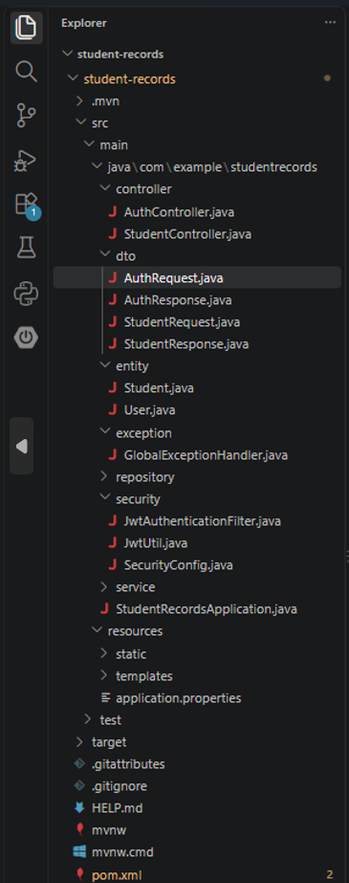

5. MongoDB Configuration
The application is configured to connect to MongoDB using:
mongodb://localhost:27017/student_records
The application uses the database:
student_records
Student records are stored in the:
students
collection.
User records are stored in the:
users
collection.
Screenshot 2 – MongoDB Compass
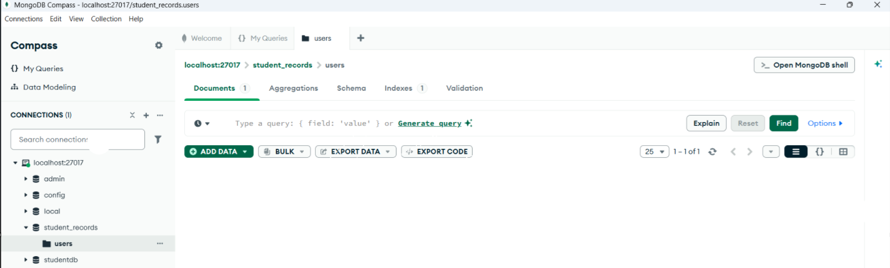
6. Application Configuration
The application.properties file contains the MongoDB connection and server configuration.
spring.application.name=student-records

spring.data.mongodb.uri=mongodb://localhost:27017/student_records

server.port=8080
The application runs on:
http://localhost:8080
The project guide specifies port 8080 and the student_records MongoDB database.
Screenshot 3 – application.properties
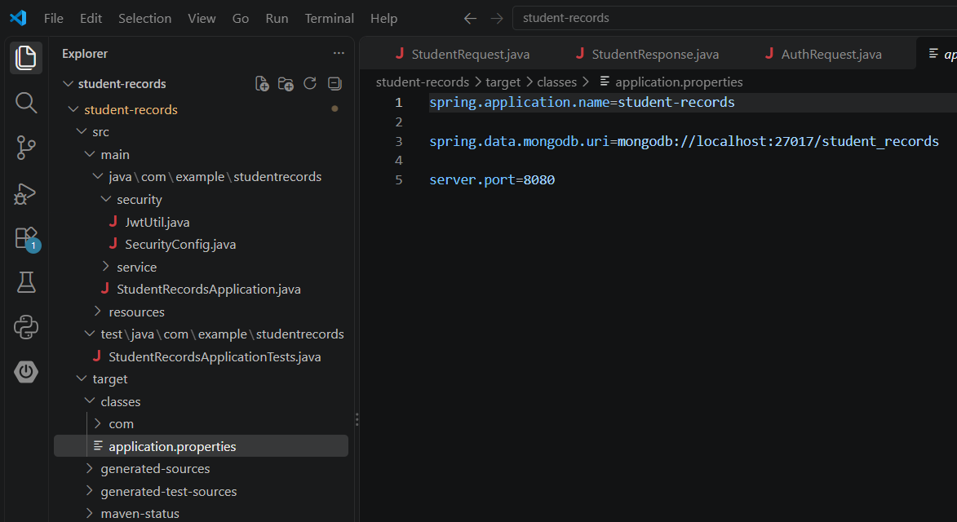

7. Project Compilation
The project was compiled using Maven.
Command used:
mvn compile
The project compiled successfully with:
BUILD SUCCESS
The compiler successfully compiled the project using Java release 17. Your final compilation showed 17 source files and BUILD SUCCESS.
Screenshot 4 – Successful Maven Compilation
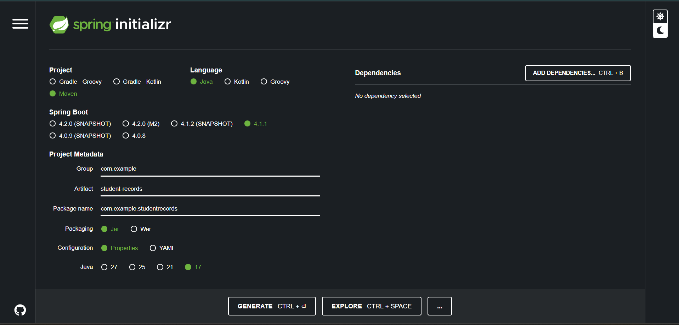

8. Running the Spring Boot Application
The application was started using:
mvn spring-boot:run
The application successfully started on port 8080.
The console displayed:
Tomcat started on port 8080 (http)
and:
Started StudentRecordsApplication
The application also successfully connected to MongoDB at localhost:27017.
Screenshot 5 – Spring Boot Application Running
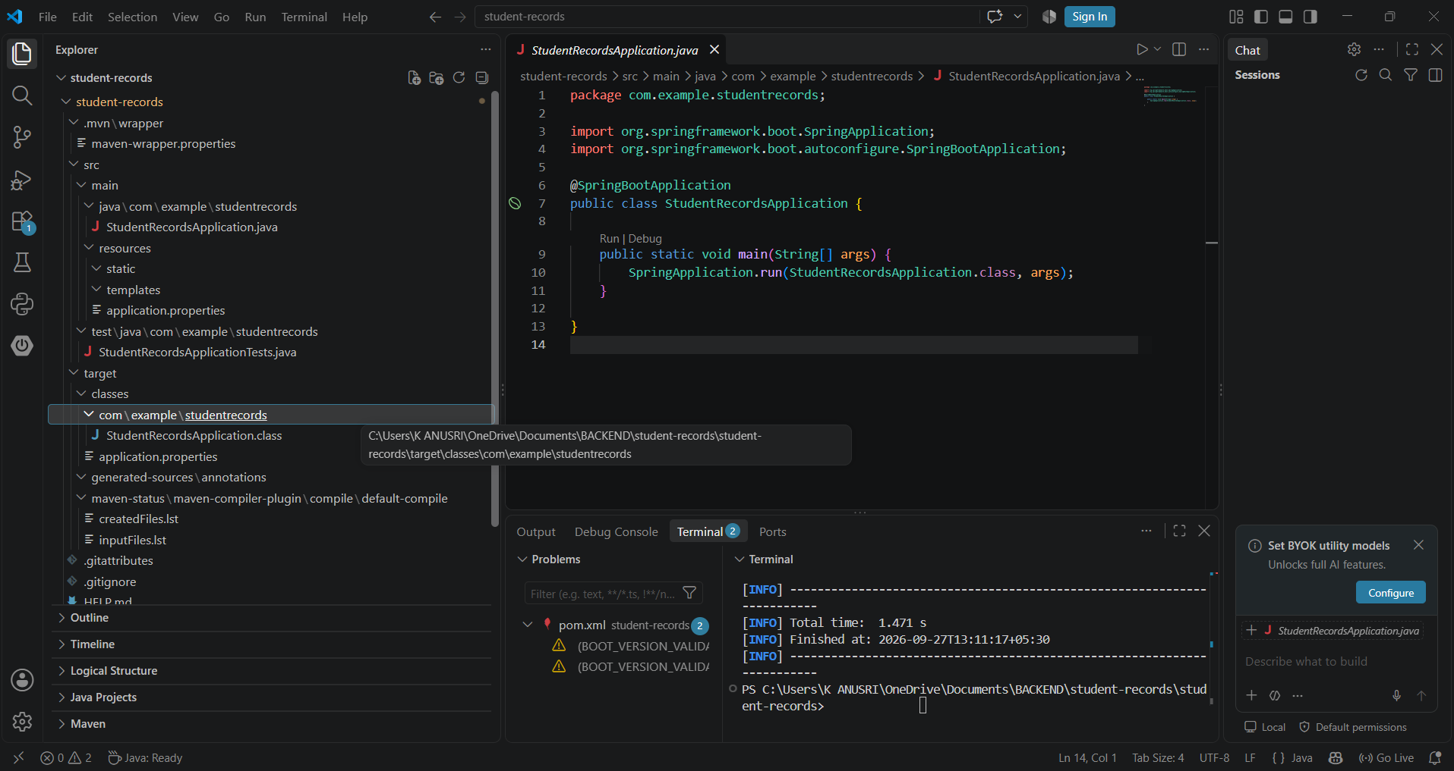

9. User Registration
The registration API was tested using Postman.
Request
Method:
POST
URL:
http://localhost:8080/auth/register
Request Body
{
"username": "anu",
"password": "123456"
}
The user was successfully registered and stored in MongoDB.
Screenshot 6 – User Registration
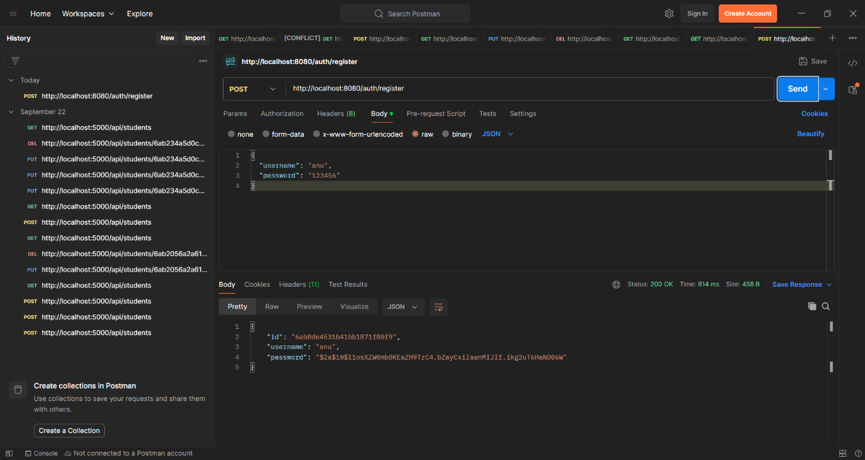

10. User Login and JWT Authentication
The login API was tested using Postman.
Request
Method:
POST
URL:
http://localhost:8080/auth/login
Request Body
{
"username": "anu",
"password": "123456"
}
The API returned a JWT token after successful authentication.
Response
{
"token": "JWT_TOKEN"
}
The JWT token is then used to access protected student endpoints.
The project guide specifies registration, login, JWT generation and use of the JWT as a Bearer token for protected requests.
Screenshot 7 – Login and JWT Token
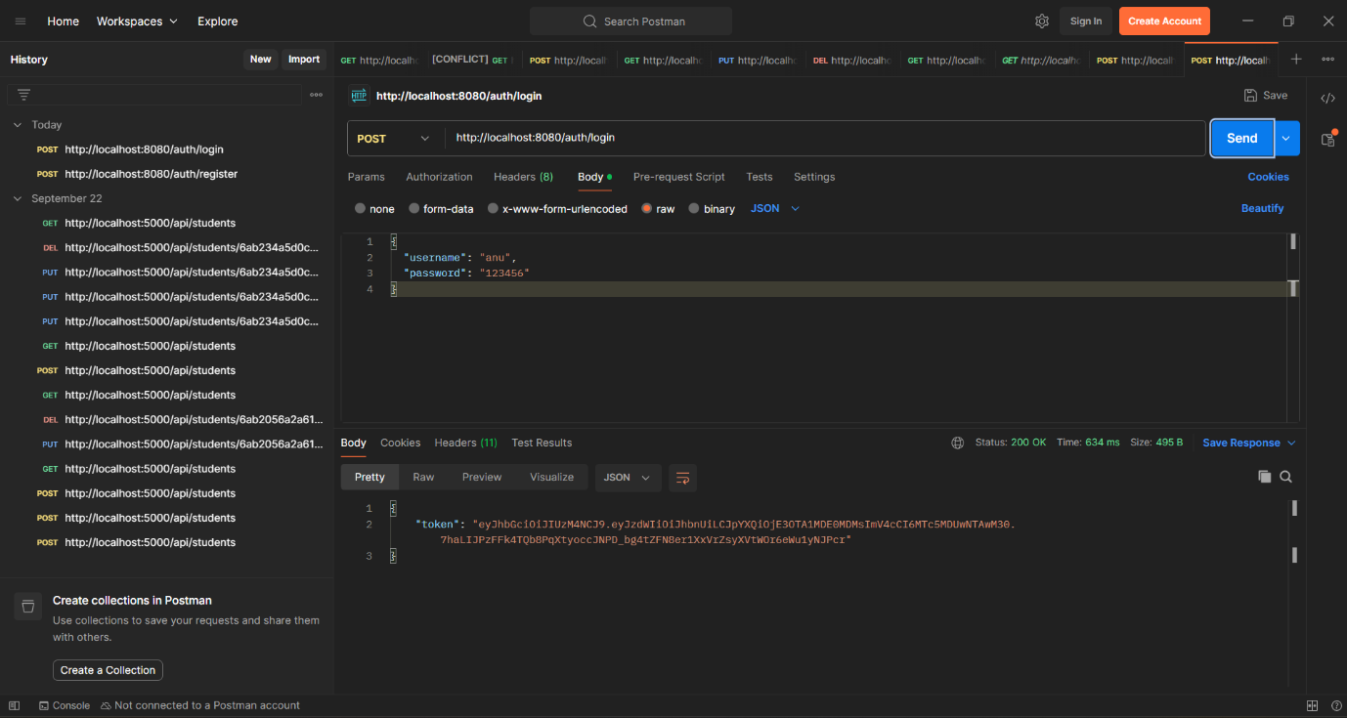

11. Create Student Record
A student record was created using the protected Student API.
Request
Method:
POST
URL:
http://localhost:8080/students
Authorization
Bearer Token
Request Body
{
"name": "Anusri",
"email": "anusri@gmail.com",
"course": "CSE",
"age": 18
}
Response
{
"id": "6ab8efb33c1168d92690dc6d",
"name": "Anusri",
"email": "anusri@gmail.com",
"course": "CSE",
"age": 18
}
Screenshot 8 – Create Student
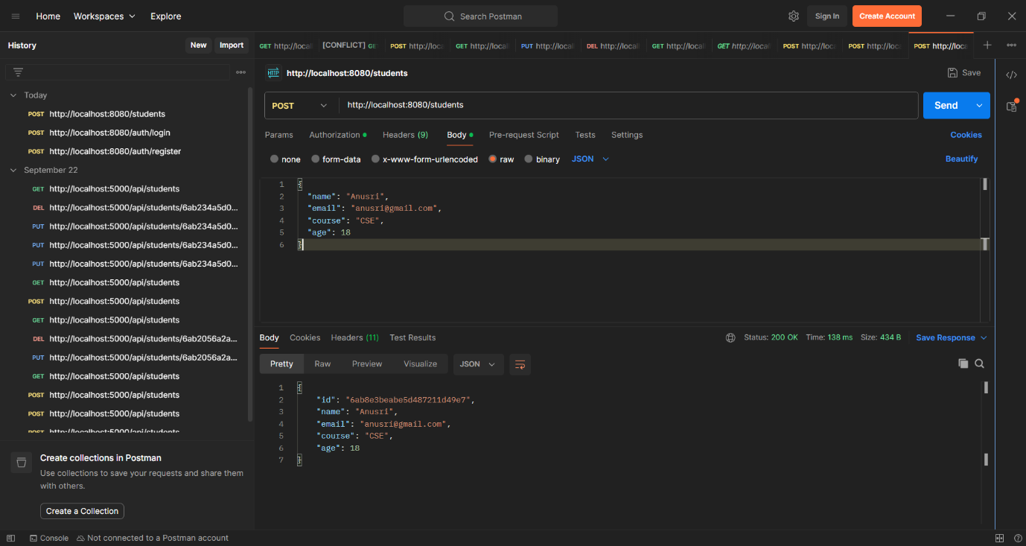

12. Retrieve Student Records
The student records were retrieved using:
Method:
GET
URL:
http://localhost:8080/students
The API successfully returned the stored student record.
Response
[
{
"id": "6ab8efb33c1168d92690dc6d",
"name": "Anusri",
"email": "anusri@gmail.com",
"course": "CSE",
"age": 18
}
]
Screenshot 9 – Get All Students
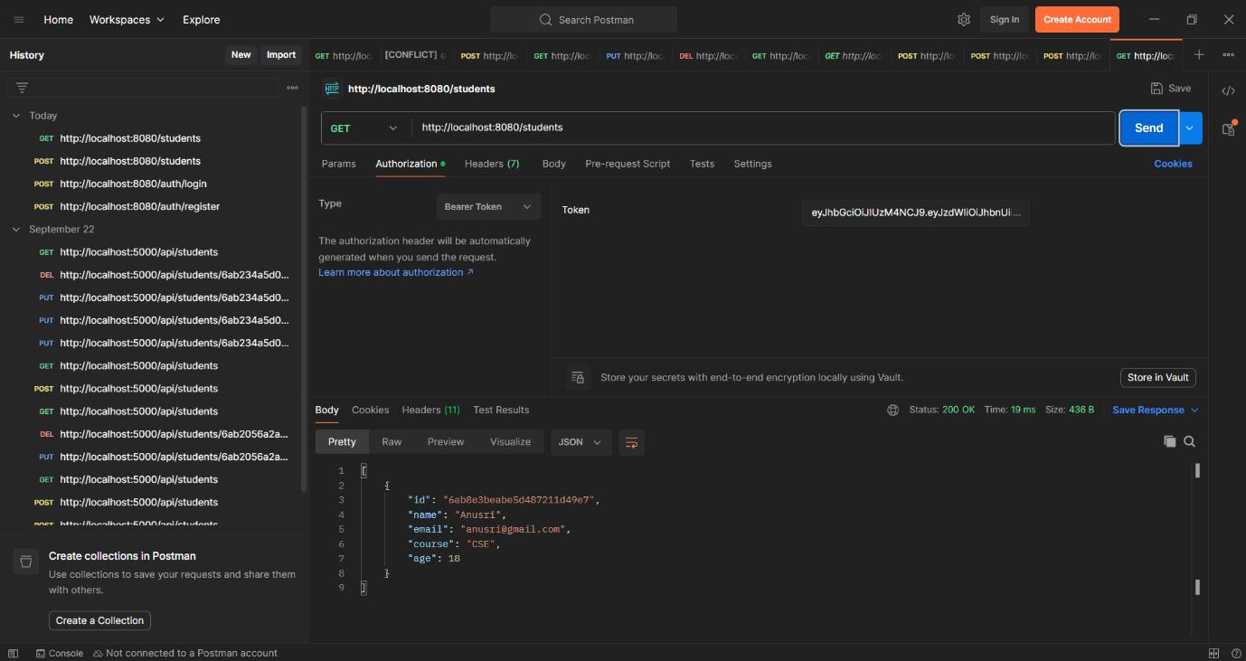

13. MongoDB Student Record
The student data is stored in MongoDB under:
Database: student_records
Collection: students
The stored document contains:
Name : Anusri
Email : anusri@gmail.com
Course : CSE
Age : 18
Screenshot 10 – Student Record in MongoDB Compass
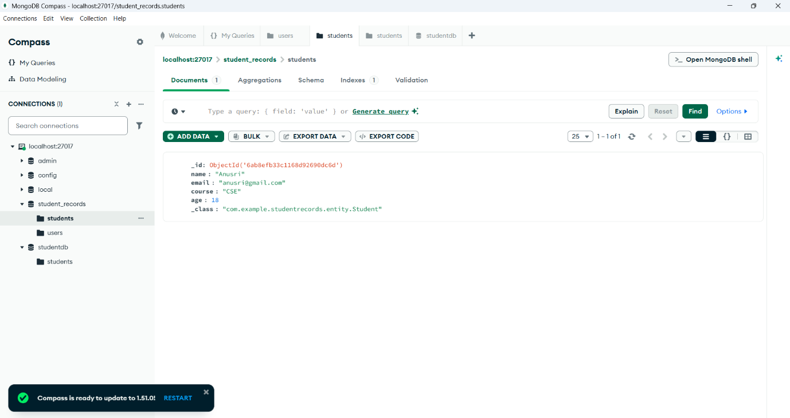

14. JWT Security Verification
The student endpoint is protected using Spring Security and JWT authentication.
A request without a valid authentication token is rejected, while a request containing the valid Bearer token is allowed to access the protected endpoint.
This confirms that JWT-based authentication is functioning in the application.
Screenshot 11 – JWT Protected Request
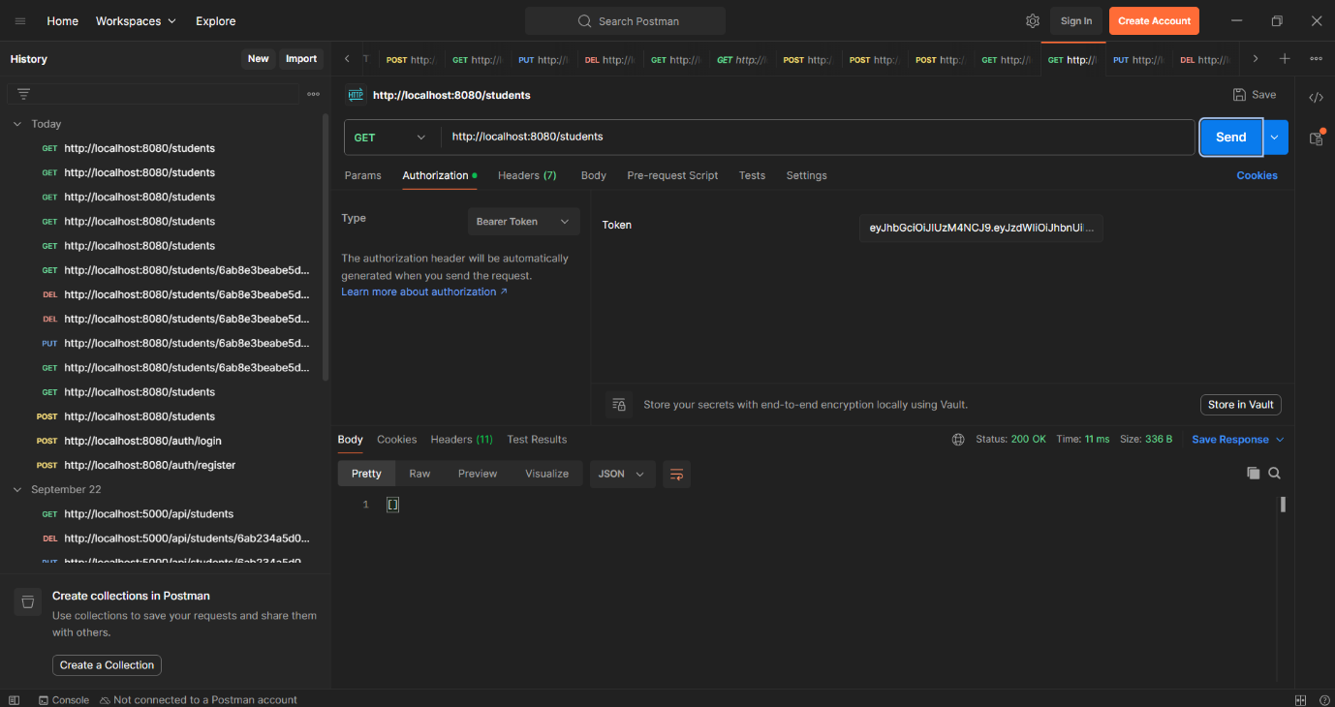

15. Result
The Student Records Application was successfully implemented using Spring Boot and MongoDB.
The application successfully demonstrated:
- User registration
- User login
- JWT token generation
- JWT-protected student API
- Student record creation
- Student record retrieval
- MongoDB data storage
The application successfully connected to MongoDB and ran on port 8080. The implementation guide describes the application as a REST API supporting student-record CRUD operations with authentication and MongoDB persistence.

16. Conclusion
The Student Records Application was successfully developed and tested using Spring Boot, MongoDB, Spring Security and JWT authentication. The application provides a secure REST API for managing student records and successfully stores the data in MongoDB.

